TITLE OF THE ARTICLE [TIMES NEW ROMAN FONT 16PT BOLD, CENTER, UPPERCASE]
For manuscripts written in Malay, a translation of the title into Malay must be provided, formatted in Capitalize Each Word [Times New Roman font 12pt Bold, Center, Italic]
Author Full Name ¹, Author Full Name², Author Full Name³, Author Full Name ⁴ [Times New Roman font 12pt Bold, Center]
¹ Affiliation, Address, Country
² Affiliation, Address, Country
³ Affiliation, Address, Country
⁴ Affiliation, Address, Country
*Corresponding author: author@mail.com

Article Info | ABSTRACT
Submitted: 10-10-2025  Accepted: 10-11-2025  Published: 10-12-2025 | The abstract should contain between 150–250 words in one continuous paragraph and must clearly and concisely present the essential components of the research. Authors should begin with a brief background that introduces the main issue of the study, its significance, and the objectives to be achieved. The abstract should then describe the research design, the context or data sources, the methods of information gathering, the participants or materials involved, and the key aspects examined. Authors must also provide a general overview of the analytical approach used. The main findings should be summarized with emphasis on the most important results relevant to the study objectives. The abstract should also identify the novelty or primary contribution of the research, whether theoretical, methodological, or practical. The paragraph must conclude with a concise statement of the study’s implications. [Times New Roman font, 11pt, Justify]  Keywords: 3 – 5 words or phrases; separated by semicolon; lowercase.
 | ABSTRAK
Abstrak hendaklah mengandungi antara 150–250 patah perkataan dalam satu perenggan berterusan dan mesti menyampaikan komponen penting penyelidikan dengan jelas dan ringkas. Penulis perlu memulakan dengan latar belakang ringkas yang memperkenalkan isu utama kajian, kepentingannya serta objektif yang ingin dicapai. Seterusnya, abstrak hendaklah menerangkan reka bentuk kajian, konteks atau sumber data, kaedah pengumpulan maklumat, peserta atau bahan yang terlibat, serta aspek utama yang diteliti. Penulis juga mesti memberikan gambaran umum tentang pendekatan analisis yang digunakan. Dapatan utama perlu diringkaskan dengan menekankan hasil yang paling signifikan berkaitan dengan objektif kajian. Abstrak turut perlu mengenal pasti nilai kebaharuan atau sumbangan utama kajian sama ada dari aspek teori, metodologi atau praktikal. Perenggan hendaklah diakhiri dengan kenyataan ringkas mengenai implikasi kajian. [Times New Roman font, 11pt, Justify, Italic]

Kata Kunci: 3 – 5 perkataan atau frasa; dipisahkan dengan tanda sempang bertitik (semicolon); huruf kecil.
This is an open access article under the CC BY 4.0


INTRODUCTION [Times New Roman font 12pt Bold, Uppercase]
Contains background, rationale, and or research urgency. References (relevant literature or research), need to be included in this section, in relation to the justification of research urgency, the emergence of research problems, alternative solutions, and the solutions chosen. The way of writing sources in the text needs to clearly indicate the name of the author and the citation of the source, in the form of the year of publication. An example APA in-text citations narrative: Research indicates that nearly 60% of university students struggle to apply theoretical concepts to real-world situations (Johnson & Smith, 2019). The problems and objectives, as well as the usefulness of the research are written narratively in paragraphs, no need to be given special subtitles. Likewise operational definitions, if deemed necessary, are also written narratively. [Times New Roman font, 11pt, Justify]
Manuscripts must be prepared using Times New Roman font, size 11, with no spacing between paragraphs. The paper size should be set to A4 (Width: 8.27", Height: 11.69"). The top, bottom, left, and right margins must follow the settings shown in the example, specifically 0.59 inches for all sides.
This is an example of the next paragraph, created by pressing ENTER once only. The paragraph spacing remains single, and no additional spacing is added before or after the paragraph unless it is a heading or subheading. This paragraph illustrates the same rule: single spacing, Times New Roman size 11, and only one line break between paragraphs. This format must be consistently followed throughout the manuscript.

Header, Footer, and Page Numbering [Times New Roman font, 11pt]
Second-level headings must be typed in boldface with capitalized first letters, as shown in this subsection heading. When preparing the full manuscript, the header and footer settings will be applied automatically according to the provided template. Authors are only required to replace the placeholder “XXX” in the header on the first page with the actual manuscript number assigned upon acceptance of the abstract. This will ensure that each submission carries a unique page identifier. [Times New Roman font, 11pt, Justify]

METHOD [Times New Roman font 12pt Bold, Uppercase]
Contains the type of research, time and place of research, targets/objectives, research subjects, procedures, instruments and data analysis techniques as well as other matters related to the method of research. targets/objectives, research subjects, procedures, data and instruments, and data collection techniques, as well as data analysis techniques and other matters related to the method of research can be written in sub-chapters, with sub-headings. Sub-subheadings do not need to be notated, but are written in lowercase with a capital letter. [Times New Roman font, 11pt, Justify]

RESULTS [Times New Roman font 12pt Bold]
Research results are presented in the form of graphs, tables, or descriptive. Analysis and interpretation of these results is necessary before they are discussed. [Times New Roman font, 11pt, Justify]
The table is written in the middle or at the end of each research result/gain description text. If the width of the Table is not enough to be written in half a page, it can be written in a full page. As an example, can be seen in Table 1. Following
Table 1. Students' ability scores to do ... on learning …
No. | Assessment Aspect | Score
Mean

The results are in the form of images, or data that is made of images/schemesgraphs/diagrams/the like, the presentation also follows the existing rules; title or image name is placed below the image. As an example, it can be seen in Figure 1. Below.

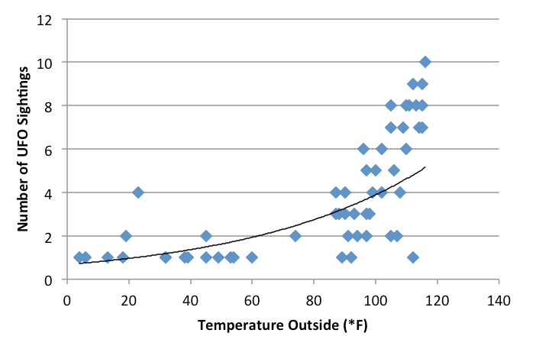
Figure 1. The effect of weather on UFO sightings

DISCUSSION [Times New Roman font 12pt Bold, Uppercase]
The discussion is focused on connecting data and analysis results with the problem or research objectives and the wider theoretical context. Could this discussion be the answer to the question why these facts were found in the data?
A written discussion is attached to the data discussed. The discussion is inseparable from the data discussed, as well as conveying the novelty in this research and its implications. [Times New Roman font, 11pt, Justify]

CONCLUSION [Times New Roman font 12pt Bold, Uppercase]
Conclusions can be generalized findings according to research problems, can also be in the form of recommendations for the next step. [Times New Roman font, 11pt, Justify]

ACKNOWLEDGEMENT [Times New Roman font 12pt Bold, Uppercase]
I would like to thank you funding for this research. This work was supported by…[Times New Roman font, 11pt, Justify]

REFERENCES
References are arranged chronologically following the APA 7 style (American Psychological Association) system. For each Reference cited in the manuscript, a reference must appear in the reference list.

